_Exercise 2

A bank has many branches and a large number of customers. Bank is identified by its code. Other details like name, address and phone for each bank are also stored. Each branch is identified by its bank. Branch has a name, address and phone. A customer can open different kinds of accounts with the branches. An account can belong to more than one customer. Customers are identified by their SSN, name, address and phone number. Age is used as a factor to check whether a customer is a major. There are different types of loans, each identified by a loan number. A customer can take more than one type of loan and a loan can be given to more than one customer. Loans have a duration and interest rate. Make suitable assumptions and use them in showing maximum and minimum cardinality ratios.

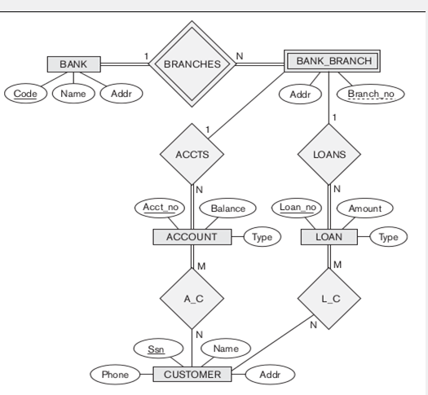

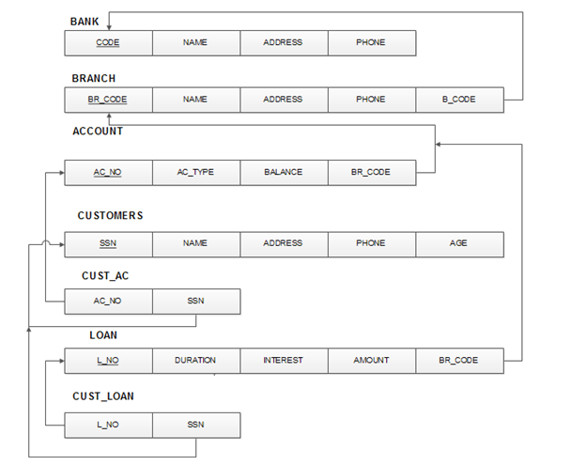

mysql> create table bank(code varchar(10) primary key,name varchar(20),address varchar(20),phone int(11));

mysql> select * from bank;

mysql> create table branch(id int primary key,name varchar(10),address varchar(20),phone int(12),b_code varchar(10), foreign key(b_code) references bank(code));

mysql> select * from branch;

mysql> create table account(ac_no int primary key,ac_type varchar(10), balance int, bid int, foreign key(bid) references branch(id));

Query OK, 0 rows affected (0.09 sec)

mysql> select * from account;

mysql> create table customers(ssn int primary key,name varchar(20), address varchar(20),phone int,age int);

Query OK, 0 rows affected (0.09 sec)

mysql> select * from customers;

mysql> create table cust_ac(acc_no int, ssn int, foreign key(acc_no) references account(ac_no), foreign key(ssn) references customers(ssn));

Query OK, 0 rows affected (0.14 sec)

mysql> select * from cust_ac;

create table loan(lno int primary key,duration int,interest float,amount int,bid int(11),foreign key(bid) references branch(id));

Query OK, 0 rows affected (0.13 sec)

mysql> select * from loan;

mysql> create table cust_loan(lno int,ssn int, foreign key(lno) references loan(lno), foreign key(ssn) references customers(ssn));

Query OK, 0 rows affected (0.13 sec)

mysql> select * from cust_loan;

INSERT INTO bank (code, name, address, phone) VALUES

('SBI', 'State Bank of India', 'Bangalore', 1234567890),

('HDFC', 'HDFC Bank', 'Mumbai', 9876543210);

INSERT INTO branch (id, name, address, phone, b_code) VALUES

(1, 'SBI Bangalore Main', 'Bangalore Main Street', 1111111111, 'SBI'),

(2, 'SBI Bangalore Branch 2', 'Bangalore Street 2', 2222222222, 'SBI'),

(3, 'HDFC Mumbai Main', 'Mumbai Main Street', 3333333333, 'HDFC');

INSERT INTO account (ac_no, ac_type, balance, bid) VALUES

(1, 'joint', 1000, 1),

(2, 'sb', 500, 1),

(3, 'joint', 1500, 2),

(4, 'sb', 200, 3);

INSERT INTO customers (ssn, name, address, phone, age) VALUES

(123456789, 'Alice', 'Address 1', 1111111111, 25),

(234567890, 'Bob', 'Address 2', 2222222222, 30),

(345678901, 'Charlie', 'Address 3', 3333333333, 35),

(456789012, 'David', 'Address 4', 4444444444, 40);

INSERT INTO cust_ac (acc_no, ssn) VALUES

(1, 123456789),

(2, 123456789),

(3, 234567890),

(4, 345678901);

INSERT INTO loan (lno, duration, interest, amount, bid) VALUES

(1, 12, 5.5, 2000, 1),

(2, 24, 6.2, 3000, 2),

(3, 18, 5.8, 2500, 3),

(4, 36, 7.0, 4000, 1);

INSERT INTO cust_loan (lno, ssn) VALUES

(1, 123456789),

(2, 234567890),

(3, 345678901),

(4, 456789012);

Queries:

a) List the details of customers who have a joint account and also have at least one loan.

mysql> select c.* from customers c,account a,cust_loan cl,cust_ac ca where cl.ssn=c.ssn and c.ssn=ca.ssn and a.ac_type="joint" and ca.acc_no=a.ac_no;

b) List the details of the branch which has given the maximum loan.

mysql> select * from branch where id=(select bid from loan where amount=(select max(amount) from loan));

c) List the details of saving accounts opened in the SBI branches located at Bangalore.

mysql> SELECT a.* FROM account a JOIN branch b ON a.bid = b.id

WHERE a.ac_type = 'sb' AND b.b_code = 'SBI' AND b.address LIKE '%Bangalore%';

SELECT * FROM account WHERE ac_type = 'sb' AND bid IN (SELECT id FROM branch WHERE b_code = 'SBI' AND address LIKE '%Bangalore%');

d) List the name of the branch along with its bank name and total amount of loan given by it.

mysql> select b.name,br.name,sum(l.amount) from bank b,branch br,loan l where br.b_code=b.code and l.bid=br.id group by l.bid;

e) Retrieve the names of customers who have accounts in all the branches located in a specific city.

mysql> select c.name from customers c,cust_ac ac,account a,branch br where c.ssn=ac.ssn and a.ac_no=ac.acc_no and a.bid=br.id and br.address like "%bangalore%";